1. Write a program in Java to demonstrate use of this keyword. Check whether this can access the private members of the class or not.
2. Design a class as shown in figure

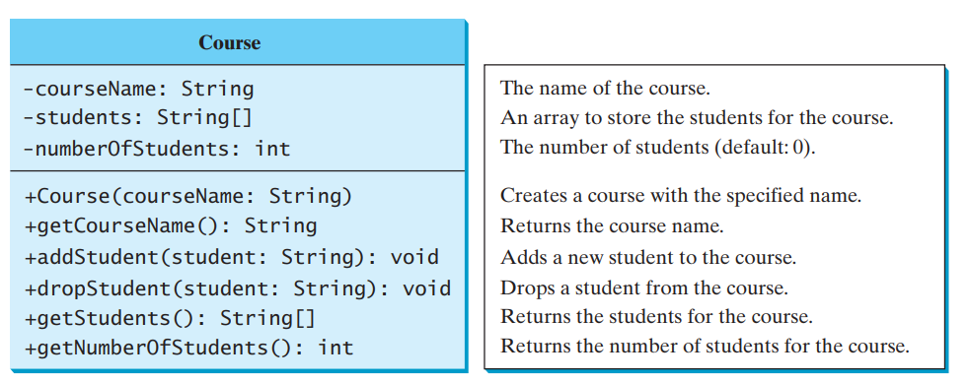

1. Write a program in Java to develop overloaded constructor.
2. Write a java program for given scenario

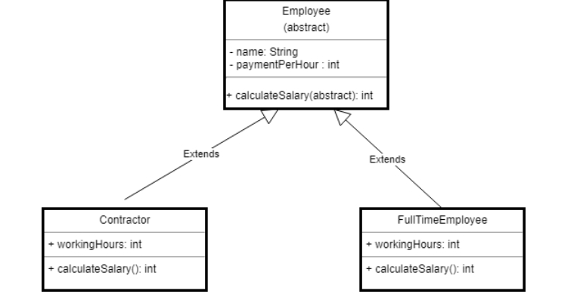

1. Write a program in Java to demonstrate multilevel inheritance in Java
2. Write a program in Java in which a subclass constructor invokes the constructor of the super class and instantiate the values.
3. Describe abstract class called **Shape** which has three subclasses say **Triangle, Rectangle, Circle.** Define one method **area()** in the abstract class and override this **area()** in these three subclasses to calculate for specific object i.e. area() of Triangle subclass should calculate area of triangle etc. Same for Rectangle and Circle
4. Re-write program 4 and 7 to use Interface instead of Abstract class.
5. Write a Java program to demonstrate multiple inheritance using interface.
6. Read the following tutorial about Math class and implement all programs given at the following link: <https://docs.oracle.com/javase/tutorial/java/data/beyondmath.html>
7. The following program demonstrates the use of GregorianCalendar class. Type this code and observe the output.

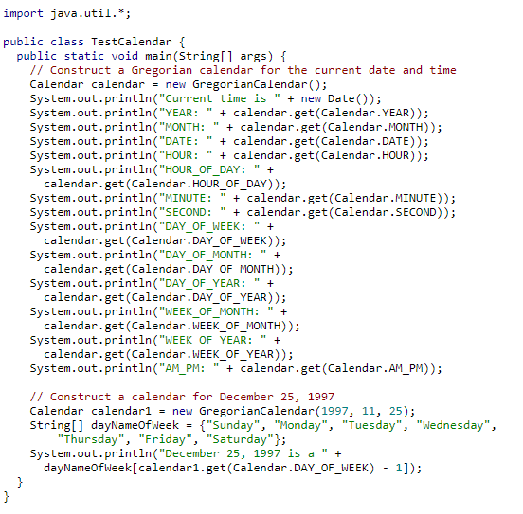

1. Write a program to display a calendar for a specified month using the Calendar and GregorianCalendar. Your program receives the month and year as input.

